tasc
traditional arts support in the community cymorth celfyddydau traddodiadol yn y gymuned
www.tradartsupport.org.uk admin@tradartsupport.org.uk
registered charity 1042144
Patron: John Kirkpatrick
TASC | Facebook

Annual Report 2022

Covering activity from 1st November 2021 to 30th October 2022

Foreword

Hello TASC members and friends!

I hope you are all well and able to get out and about to enjoy some traditional music, dance and song. We, TASC trustees, are endeavoring to do our bit to help make this possible as per TASC’s ‘raison d’être’:
…to promote the use of Traditional and tradition-based Arts in the Community by programmes designed to increase participation and
raise standards.
Read on to find out what we have been up to.

We are also planning our programme for the next 12 months and beyond – do let us know if you have any ideas for events, can offer any practical help or know about any funding possibilities.

Wishing you all a happy and healthy year!

Louise Williams
Chair – TASC
February 2023

Activities

We continue to promote folk arts events through our facebook page and our website.

Northumbrian Small Pipes Workshop

On the 3rd of September 2022, TASC hosted a Northumbrian Small Pipes workshop in Bishops Castle. The session was sold out within days of being advertised and was led by a leading exponent of the pipes, Ednie Wilson. Ednie, from Gateshead, is an expert tutor of these instruments which make a sound that is iconic for the region. She weaves into her sessions the history and culture of the area, creating a unique experience for the group.

None of the participants had any prior experience of the small pipes, so they all explored the pipes and had them ‘fitted’, before starting with a gentle exploration of the basic techniques which involved something akin to rubbing your tummy whilst tapping your head, resulting in great hilarity for everyone. Ednie’s gentle, humour-filled and highly-skilled guidance resulted in everyone making a good sound and actually playing a proper tune together by the end of the half-day session. A huge thanks to Ednie, all who came, and TASC trustee Kay who organised the event.

We are exploring the possibility of putting on another of these workshops later in 2023.
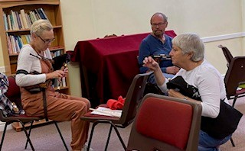

Welsh Folk Day

We are very pleased to have been able to put on this day of Welsh music, dance and song in Llandrindod Wells on the 15th of October 2022.

The event took place across three venues: the Dance Centre, the outdoor Bowling Club and the Heritage Centre, Rock Park, with workshops in
- Welsh Clog dance – lead by the marvelous Huw Williams
- Welsh folk tunes – lead by the knowledgeable Jem Hammond
- Welsh folk song – lead by the wonderful Menna Thomas
The day culminated with a ‘showcase’ where each group shared what they had learnt during the day.

Here is a flavour of the feedback we received:

“I had a great time. Menna did a really good job as tutor and I thought the showcase at the end was such a good idea. It gave a focus for the day and it was great to have the opportunity to see what the other groups had been working on.”

“thank you for arranging the very enjoyable Welsh Folk day yesterday. It was great to have a chance to try some clog dancing”

“Good venue. Excellent tuition. Lovely step variety and explanation. Wonderful to have live music accompaniment. Will take what’s learnt back to my dance group. Thank you!”

“Thank you, I had a great time. Huw is a great teacher, and the pace was good.”

“A most enjoyable experience. Singing teacher was excellent. Worth doing again.”

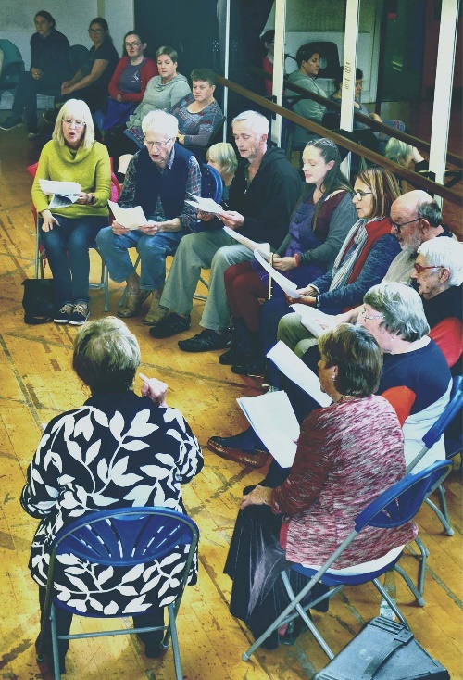
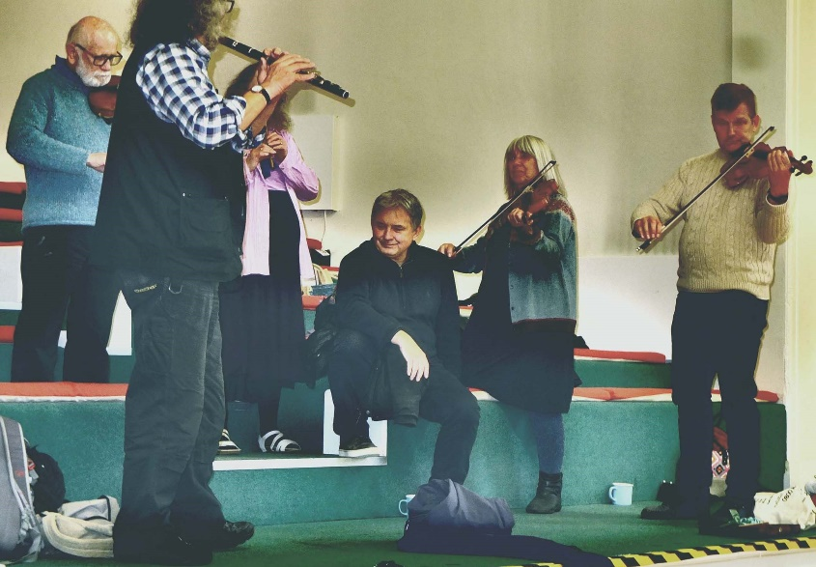

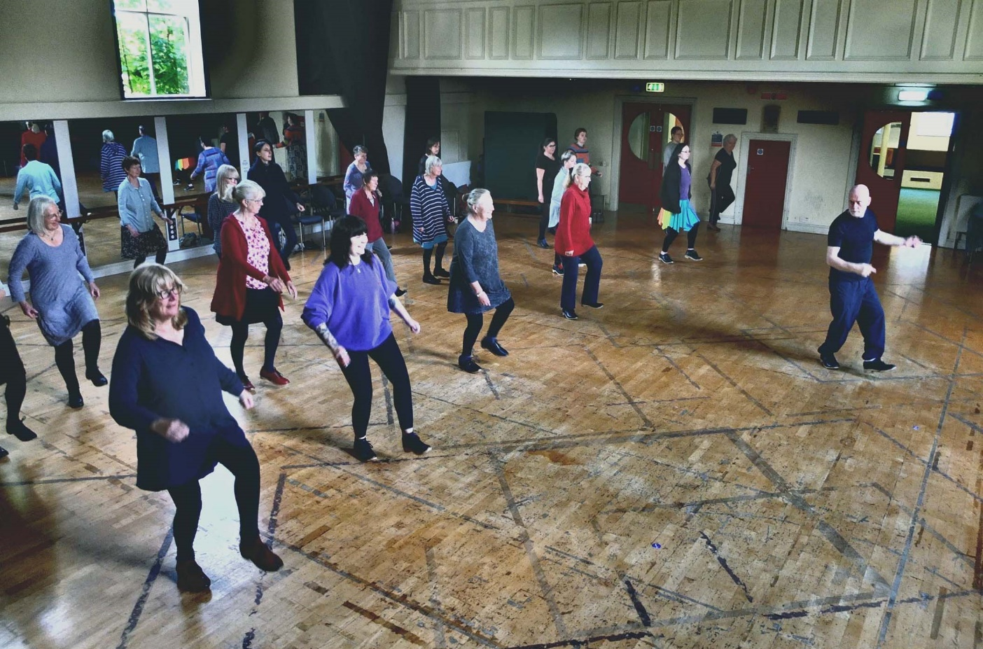

The Seven Stars Steady Session

This TASC session takes place at the Seven Stars Inn, Aberedw, from 7.30pm to 9.30ish on the third Monday of each month. (It has almost become a dining club too, as many of our number make an evening of it by having a meal at the pub first!)

We play a variety of traditional Welsh, English, Scottish and Irish tunes at a steady pace. Any acoustic instruments are welcome - we currently have fiddles, recorders, whistle, melodeon, bouzouki, guitars, banjo and harp. Our core tune list can be found on the TASC website, and we are expanding our repertoire all the time – we play some beautiful waltzes, and also the occasional classical tune!

In December 2021, three of us provided live music for a senior citizens’ Christmas tea, put on by Rhayader WI.

Update on TASC’s group members:

Monty Folk

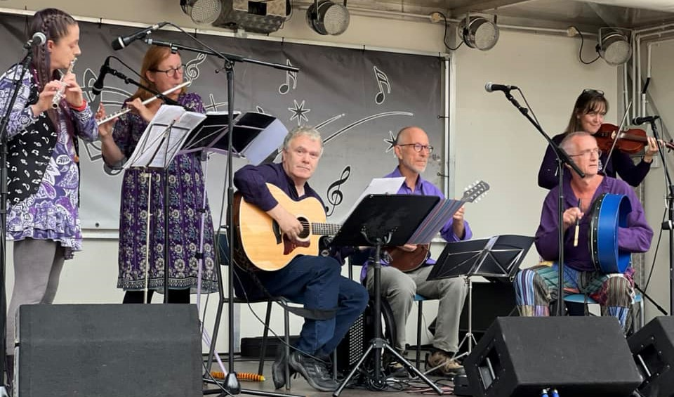

On stage at Newtown Food Festival, Sept 2022
Last year, we left Monty Folk in Christmas mode, digging out seasonal tunes old and new, from near and far. Sadly, the scheduled Christmas “outings” were cancelled by further concerns about gathering in numbers. However, five members and a backing spaniel (!) managed to gather in the church with our Christmas jumpers and winter hats to have a quick but chilly play and make a little video greeting of “Joy to the World” and Hungarian carol "Kiskarácsony, Nagykarácsony", sent over by Dorothy from the Kodály violin school. A few festive tunes also brought some Christmas cheer to Montgomery Market as four players busked to help raise funds for young flautist Catrin, who has been selected to represent Wales at the World Scout Jamboree in South Korea in 2023.
What a joy it then was to play and sing together at community events again, starting with the happily rescheduled Winter Tea in February, and continuing with a Community Fayre, Hungarian Day, Literary Festival, Open Gardens…
Monty Folk and Mayor Jill Kibble brought community members together to learn, sing and record “Calon Lân” and “Ha én rózsa volnék” to celebrate St David’s Day and the Hungarian national day, which are both in March. Community members had a quick lesson in the tunes and pronunciations, then put on the shared colours of red, white and green, and recorded the songs, all in a single evening. Lydia said, “We loved the songs, and the words feel particularly relevant today. Music is an international language connecting us all.”
As spring arrived, al fresco playing was the order of the day. We busked in the sunshine at the coffee morning and art auction to raise funds for Médecins Sans Frontières and Red Cross working in Ukraine and with Ukrainian refugees; we played the Welsh and Hungarian anthems at the unveiling of the plaque to poet János Arany alongside children from the Kodály violin school; we helped the town celebrate the Platinum Jubilee at its community street party.
A fine afternoon of fun and frolics was had at the Legendary Faery Festival in Llangollen - Monty Folk’s faery festival debut and a great excuse for some excellent outfits. It was too hot for a lot of dancing but it was great to see some younger audience members shaking a wing!
Another August outing was an extra special occasion as we played tunes and called dances for a full wedding ceilidh in Montgomery Town Hall where two of the players, Jenny and Jeremy, also doubled as the bride and groom! There were happy dancers and just the right balance of witches’ reels, farmers’ jigs and bouncing about to the B52s afterwards. The stage decor even matched our band purple.
After kicking off the fun at Newtown Food Festival in the autumn with a set on the main stage, we switched seasonal gears and brought out songs and tunes for winter and Christmas, working together with Côr Trefaldwyn to celebrate the season and prepare to share some winter warmth with the community.
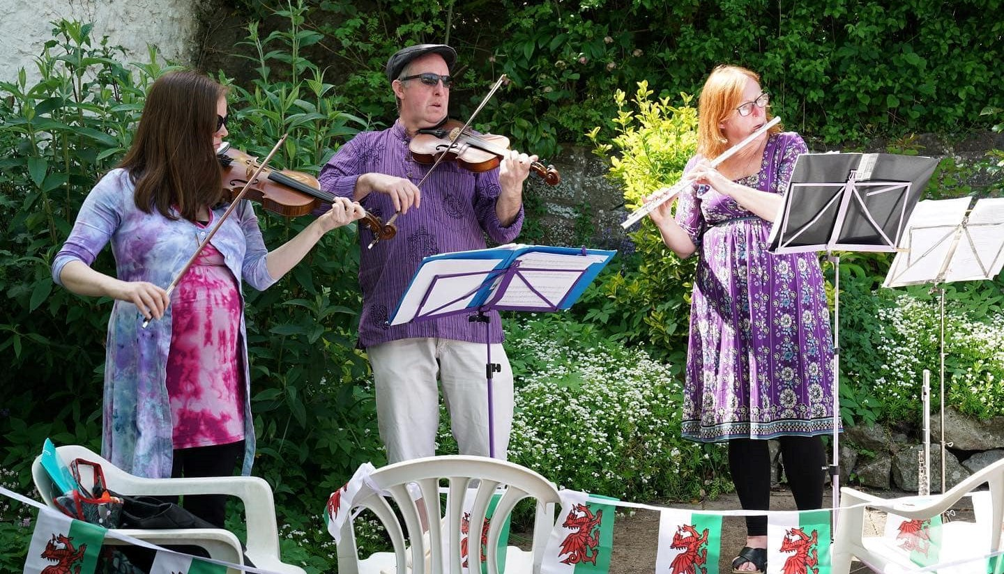

Montgomery Hungarian Day, May 2022

Rapsquillion

South West Shropshire-based folk group Rapsquillion had a busy 2021-22, although we started the period reeling with the loss of our friend and bandmate Dave Wright. We were a booked for a gig the day after he died and, although we decided that we would go ahead, it was definitely one of the hardest things we’ve ever had to do.
We also had bookings to sing at a couple of Christmas concerts. The dreaded virus was still causing chaos resulting in the cancellation of our various plans. We didn’t want the rehearsals to go to waste so decided to make a recording using smart phones and a bit of basic software. We turned it in to the Rapsquillion virtual Christmas card – it’s at Gaudete! - YouTube.
2022 started, as usual, with our February concert and workshop as part of the Bishops Castle Arts Festival. We’d been working hard on new material and the sell-out audience in the Town Hall appeared to enjoy our offering. We were joined on stage by our friends from South Wales, Greg Rowlands and Paul Frowen – thanks to them for adding a bit of class to the evening!
We were joined in March by Gordon Citrine and Chris Hall, two excellent musicians and singers who have added a new balance to Rapsquillion’s sound, as well as contributing to arranging material and bolstering our instrumental accompaniment.
Our festival year got off the ground with Fishguard Folk Festival, back after a two-year hiatus. It’s always pretty full-on for us with a couple of concerts, singarounds and workshops but it was great to see old friends again.
We went on to sing at Warwick Folk Festival, the Middlewich Folk and Boat Festival and then, in August, our regular trip to Shrewsbury Folk Festival. We were amazed to see 200 people at our harmony workshop, the majority of whom joined us for a ‘flash mob’ in the food tent at lunchtime. Sorry about the indigestion folks!!
Amongst other things we also managed to fit in singing at a Ukraine fundraiser in Bishops Castle, a couple of performances at the inaugural Bettws Triangle Arts Festival, a concert with our old friend Val Littlehales at Culmington Village Hall and a mini-tour taking in Llantrisant, Newport and Valley Folk Clubs on consecutive nights.
And, of course, along the way we’ve met old friends, made new ones and generally had a very jolly time – thanks to everyone, including TASC, for the support.

Castle Carols

Late October saw us blowing the dust from the songbook, stocking up on the honey, glycerine and those horrible little pastilles for when you have no voice, and generally girding our loins for the start of the fifth season of Castle Carols. As usual, proceedings went ahead under the tutelage and beady eye of local folk legend (and TASC patron) John Kirkpatrick. John has written the arrangements of most of the old carols sung by the group and for 2021-22 he’d also come up with a couple of new challenges.
As has become the norm, the weekly practice sessions at The Three Tuns in Bishops Castle were also transmitted via the ‘Zoom’ platform to far-flung members of the group based all over the UK as well as in Europe and across the USA – friends who joined us as during the pandemic and who wanted to carry on singing these joyous songs.
Averaging between forty and fifty people in the pub and twenty or so on-line for practices, we were looking forward to the ‘Big Sing’ on Boxing Day, which regularly attracts two hundred or more singers and spectators to The Three Tuns.
For more information on how things progressed during the 2022 season of Castle Carols, please visit the website at https://castlecarols.com, or have a look at our Facebook page.

Ffonic

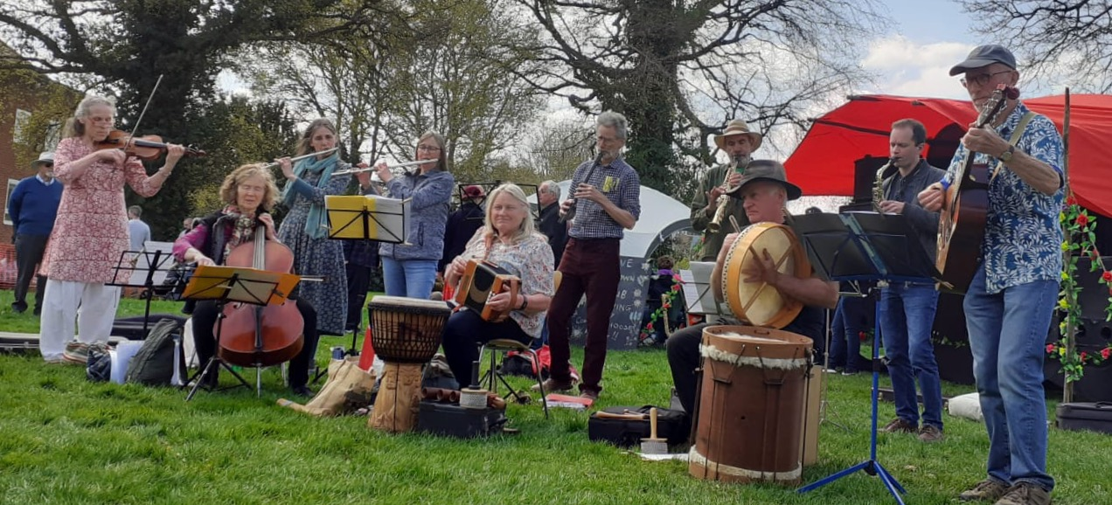

Ffonic continued to hold weekly rehearsals following our post-pandemic re-emergence after a very quiet 2020 and fortunately maintained our core membership, which had fallen to our lowest in our 23-year history. We were delighted to welcome new fiddle player, Penny, in September to boost our string section and bring our active players up to 11.
Our first gig of this period was for Newtown U3A at Plas Dolerw on Dec 1st where we played a set designed for listening to, rather than our usual more robust ceilidh sets.
By contrast, three days later we were playing with rather cold hands outside Oriel Davies for a Winter Arts Event organised by the Gallery. We shared the programme with the enthusiastic Hafren Community Choir and it was a jolly – if chilly – occasion!
We returned to the Gallery in April, again partnering Hafren Choir to perform both inside and outside at a Spring Fair event.
Band members played for a children’s procession and dancing at the Robert Owen commemorative event on May 12th.
We played for a well-attended event for Newtown Outdoor Festival in June with caller Lisa Sture and for an informal garden party at Dol Llys, Llanidloes.
Sunday Sept 4th saw Ffonic delighted to be back on stage at Newtown Food Festival playing to a large crowd enjoying the event after a 2-year Covid-enforced absence.
We were at Mid Wales Arts Centre in October for a 50th Wedding Anniversary Ceilidh. Either the venue was rather small or there were a lot of people there, but we ended up fighting the artworks on the wall for space to play.
Our season finished on a high note at the Newtown Lights Switch-On event on November 26th which was a blustery/drizzly evening for outdoor music-making, but nonetheless great fun to be part of.
Organising a community folk band can present unexpected challenges, since many booking enquires are for summer events, during public holidays, which are frequently the times when band members and/or callers are also away. Reluctantly we have to decline these rather than go out with a band which does not fully reflect the instrumental line-up people would expect to hear when they choose to book Ffonic in the first place.
Overall we are pleased our diary has been comfortably full for the past year. We’ve been able to play for a wide range of private and community events and to meet our main aim of providing affordable folk music for local events; not to mention the enjoyment we ourselves get out of sociable music making.

Raise the Dust

We are delighted that the Appalachian Step Dance team Raise the Dust joined us as group members in October 2022.

Structure and Governance

Trustees serve three years before standing for re-election.
Existing trustees are: Louise Williams (chair), Kay Hedges (vice-chair), Claire Weston (treasurer), Trevor Hedges, Lisa Sture, Sue Jelleyman and Jon Bell.

Meetings

The AGM 2022 was held at the Dragon Hotel, Montgomery, on the 20th March, with an option to join online. Afterwards we had a very enjoyable music and song session at the Montgomery Town Hall.

Policies

Induction training is provided for new trustees and Governance training is offered on an ongoing basis.
The Constitution forms the basis of governance and policies are operated for guidance in the following areas:
- Equality and Inclusion
- Welsh Language
- Safeguarding
- Recruitment of People with a Criminal Record
- GDPR
- Procurement Policy
- Project Development Protocol

In addition, risk assessments and a Health and Safety Plan are produced for all events open to the public.

Administration

The day-to-day running of TASC, along with financial management, e-news, website updates and artistic direction are shared between the trustees and co-ordinated by the Chair.

Membership

Membership is open to all who support TASC’s aims; group membership is also available.
TASC currently has 13 individual members and 5 group members.

The annual membership period runs from 1st April to 31st March.

Accounts

The annual accounts for 2021-22 are shown below. The turnover of the organisation falls below the threshold dictated by the Charity Commission for a full audit, but a regular inspection of the accounts takes place by a qualified person.

The Bank Account is currently held at

HSBC
The Cross
Newtown
SY16 2LS
